Avontece Cabrera

SWDV 665

4/24/21

**Questions and Screen Shots**

SWDV-665/week-6-groceries-app-restful-services-ACabrera-Codes

https://github.com/ACabrera-Codes/groceries.git

1. How many hours do you estimate you used completing this assignment? 4
2. What was easiest for you when completing this assignment? modules
3. What was the most difficult challenge you experienced when completing this assignment? personal family issues causing time management problem

Testing Curl create update and deleting items

Groceries database:

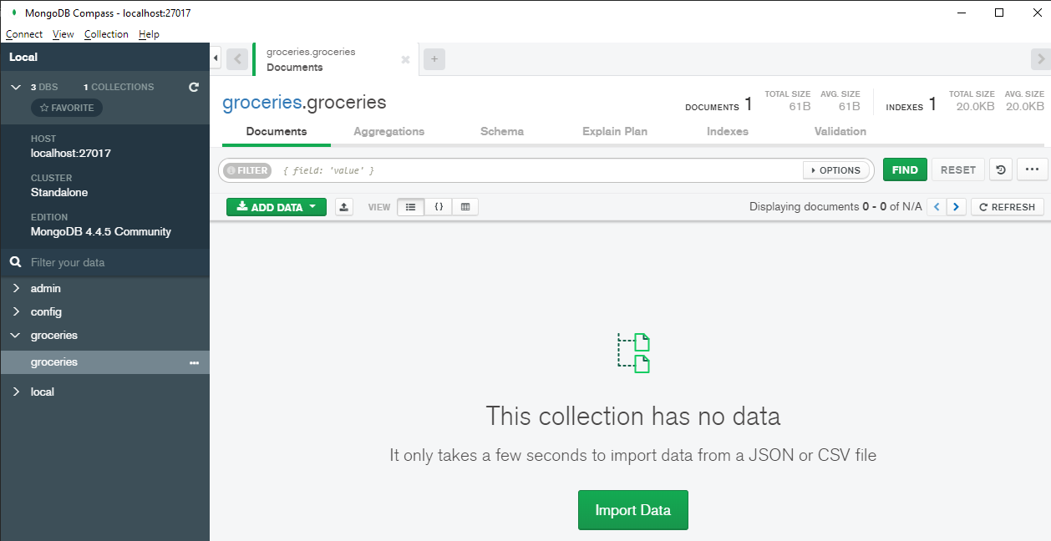

Create item :

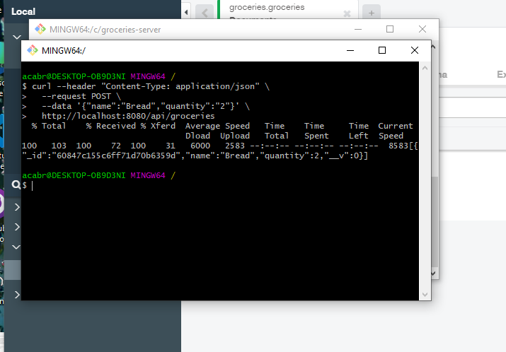

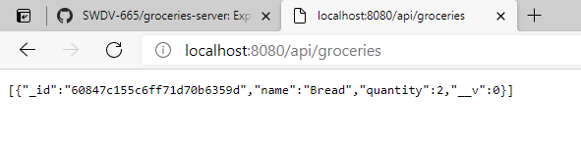

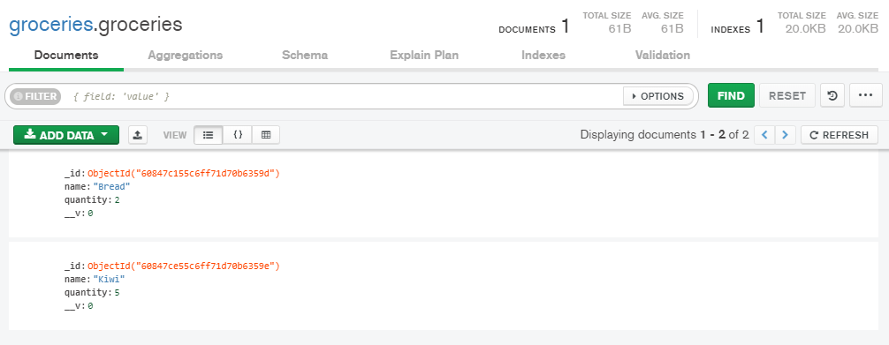

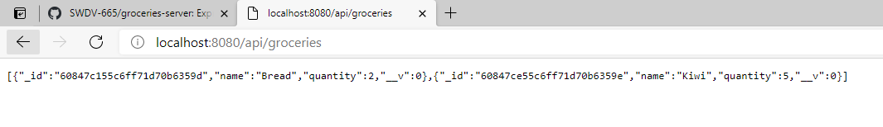

Update item:

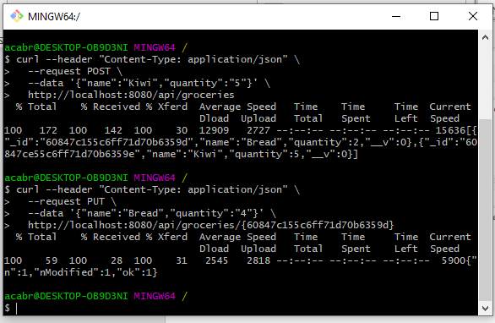

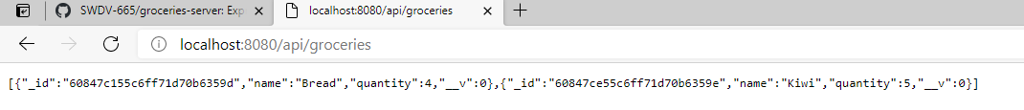

Delete items:

